

**Project Technical Memorandum**

**Date**: July 31, 2020

**To:** Jennifer Hecker and Nicole Iadevaia (CHNEP)

**From:** Justin Saarinen (ESA)

**Copied:** Doug Robison (ESA), Mark Rains, and Kai Rains (CEI)

**Subject:** CHNEP HRN2 Climate Change

______________________________________________________________________

The purpose of this task is to understand and model how non-tidally connected habitats targeted for restoration may be affected by hydrological alterations due to climate change. ESA completed a workshop with the following objectives: a) define key influencing factors driving the distribution of HRN habitats (task 1 classifications) in the non-tidal Caloosahatchee watershed; b) identify the best available geospatial datasets (including surrogates) that characterize these factors; and c) determine how these factors may be altered from projected changes in climate (year 2070) as modeled by the latest IPCC report. We found the following as key influencing factors that will be altered due to climate change as scientific knowledge base and background to our study.

1. Sea Level Rise: Increased chlorides due to salt water intrusion from rising sea levels have not been studied to be a factor in this watershed. The Franklin Lock have been designed by the Army Corps of Engineers to prevent saltwater intrusion, and there is no evidence that this design is failing (e.g., no halophytic vegetation present above the lock). SFWMD modeled the current position of the 250 mg/l isochlor and it does not extend above the structure.
2. Drying: While event driven precipitation amounts increase by 10%, the constant evapotranspiration or ET is projected to increase by 7% (Rains et al 2013). Because ET is a constant climatic factor, the volumes of water associated with rates of ET dwarf those of precipitation. Thus groundwater levels are projected to be much lower in 2070. Additionally, a drier climate will inevitably lead to increased groundwater withdrawal for agricultural and potable supply. The demands are not fully modeled in SFWMD, nor are the impacts to groundwater so this will be a difficult factor to support with certainty in this work.
3. 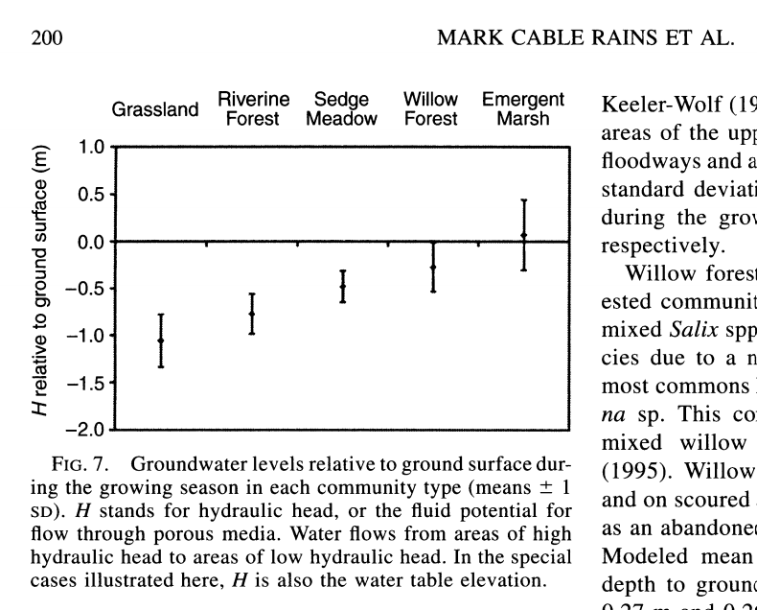Habitat migration: The classification and mapping of habitats at the scale we are modeling them in the HRN have upper and lower bounds for depths to groundwater. This has been studied well by Rains et al 2004 and Hammersmark et al 2010. See the following figure extracted from Rains et al 2004. When allowed and without prevention from hard development, plant communities will migrate with their statistical norms of depth to groundwater.

With this background we formed the conceptual model for this non-tidal watershed. Forcing from climate change is the drying of groundwater (increased evapotranspiration). Water levels in wells will be lower, and the duration time of groundwater observed at shallow depths will be less. For example, the amount of time that groundwater is present at a depth of 18 inches will decrease from 20% to 15%, or 73 days to 55 days in an average year. According to Florida native species planting guides, soil moisture at depths 10-18 inches are critical for seedling recruitment and establishment for wetland trees. Plant communities that compose habitats are limited by this duration of available water at shallow depths (Cameron et al. 2020). Thus, as groundwater duration is lessened at depths available to plants, they will migrate away from dry areas. The current distribution of habitats will be altered.

Methods:

To inform and implement this conceptual model we identified two important datasets.

SFWMD DBHYDRO well observations

SFWMD 2016 FLUCCS level 4 land cover

We extracted time series water level data from 22 wells in and within proximity to the watershed and transformed the heights above mean sea level NGVD29 to depths below ground surface, and then formed a regression model (cumulative distribution function) of the time duration water is observed at depth for each well. We selected the duration of 18-inches of depth for each well location and then modeled a continuous surface using an ordinary spherical krig to predict the duration of water at depth across the watershed (Jie et al. 2013). We performed a zonal statistics analysis for each native habitat (FLUCCS level 4 land cover), and generated summary statistics for each native natural habitat to form the average, lower bound (1 standard deviation below the mean) and minimum (lowest value) duration at depth. Scenarios of future duration at depth were modeled by lowering the current duration surface by 3%, 5%, 8% and 10%. The lower bounds and minimum duration for each habitat were compared with each alternative duration surface, resulting in a series spatially explicit models for habitat areas at risk of alteration. All analyses were performed with out of the box Esri ArcGIS Pro 2.x Spatial Analyst tools and Python scripting managed with Jupyter Notebooks.

It is important to note that while land use was used in the HRN2 Additive Hybrid analysis, land cover is used in this HRN2 climate change analysis for the reason that land cover describes the landscape characterization defined by vegetation, while land use is defined by the societal designation. In this way, native vegetation communities such as Cabbage Palm wetlands with a land cover of 6180 that are within a land use of single family residential will be included in this study. The additive hybrid designations will still remain consistent.

Results:

The results of this study identify areas in specific habitats that are at-risk to alteration due to groundwater drying conditions from climate change. The following table summarizes the habitat area at-risk of alteration for the 4 drying scenarios, 3%, 5%, 8% and 10%. Threatened habitat areas where the 18-inch depth duration drops below a standard deviation of mean wetness and Endangered habitat are areas that are below the minimum range of wetness. It is important to note that as drying intensifies, threatened habitat areas become endangered. The ‘Freshwater Marshes / Graminoid Prairies Marsh’ habitat (FLUCCS 6410) is most at risk with between 37% and 58% of the existing habitat area at-risk of alteration (threatened or endangered) due to climate change.



The following maps show the extent of at-risk habitats for each drying scenario:

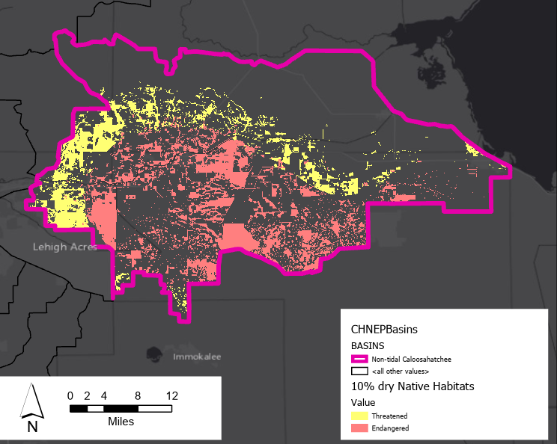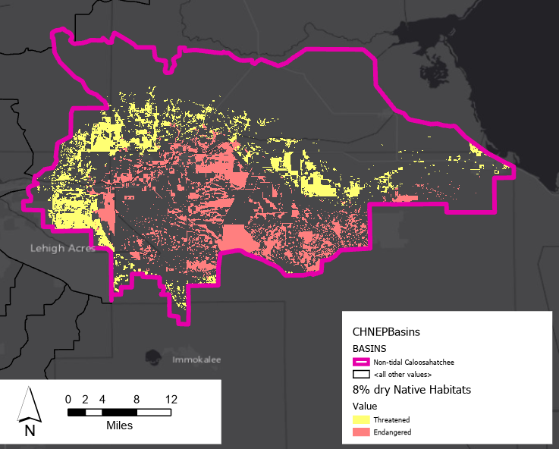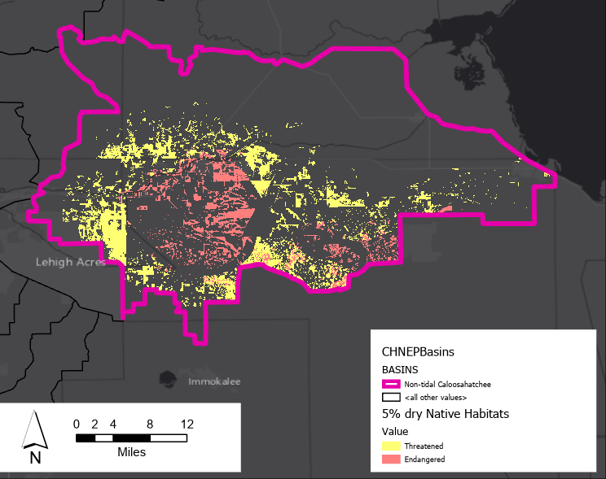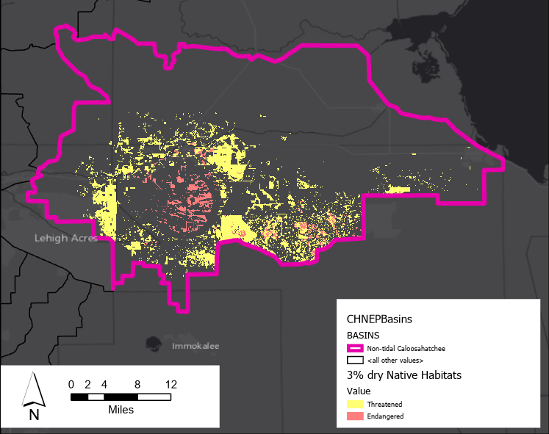

Here is a link to a web map with the preliminary results for each drying scenario: <http://arcg.is/PLqXb>

Next Steps:

The project team will need to work with CHNEP staff and TAC members to apply the results of one or more of these drying scenarios to lands identified in the Additive Hybrid model. For example, MET (Management/Enhancement Targets) that are ‘endangered’ under the 5% drying scenario could be considered in a special designation.

References:

1. Rains, M.C., Landry, S., Rains, K.C. et al. Using Net Wetland Loss, Current Wetland Condition, and Planned Future Watershed Condition for Wetland Conservation Planning and Prioritization, Tampa Bay Watershed, Florida. Wetlands 33, 949–963 (2013).
2. Rains, Mark Cable, Jeffrey F. Mount, and Eric W. Larsen. "Simulated changes in shallow groundwater and vegetation distributions under different reservoir operations scenarios." Ecological Applications 14.1 (2004): 192-207.
3. Hammersmark, Christopher T., et al. "Simulated effects of stream restoration on the distribution of wet‐meadow vegetation." Restoration Ecology 18.6 (2010): 882-893.
4. Florida Native Species Planting Guide accessed from: <https://efotg.sc.egov.usda.gov/references/public/FL/612-fl.guidance.A.pine.pdf>
5. Cameron, Cortney R., et al. "Hydroperiods of Cypress Domes in West-Central Florida, USA." Wetlands (2020): 1-10.
6. SFWMD DB Hydro database accessed from: <https://apps.sfwmd.gov/WAB/EnvironmentalMonitoring/index.html>
7. SFWMD 2014- 2016 Land Cover accessed from: <https://geo-sfwmd.hub.arcgis.com/datasets/sfwmd-land-cover-land-use-2014-2016>
8. C. Jie, Z. Hanting, Q. Hui, W. Jianhua and Z. Xuedi, "Selecting Proper Method for Groundwater Interpolation Based on Spatial Correlation," *2013 Fourth International Conference on Digital Manufacturing & Automation*, Qingdao, 2013, pp. 1192-1195